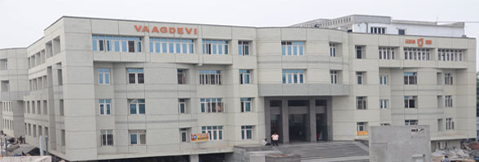

Vaagdevi Degree & P.G. College

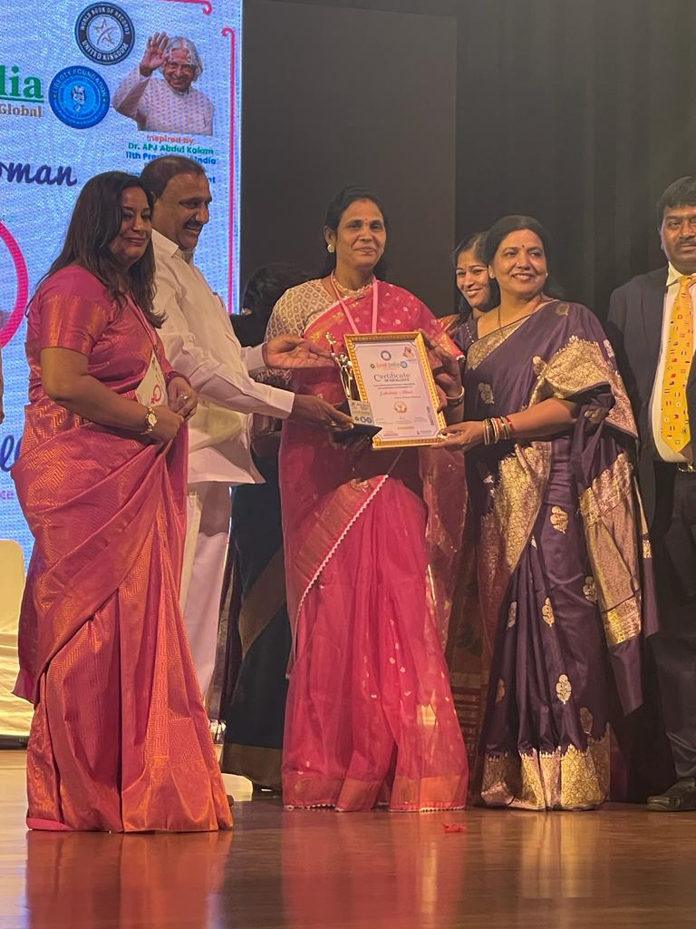

Dr.Ch.Vahini Devi Garu Director , Vaagdevi Colleges – “Power woman “ Award

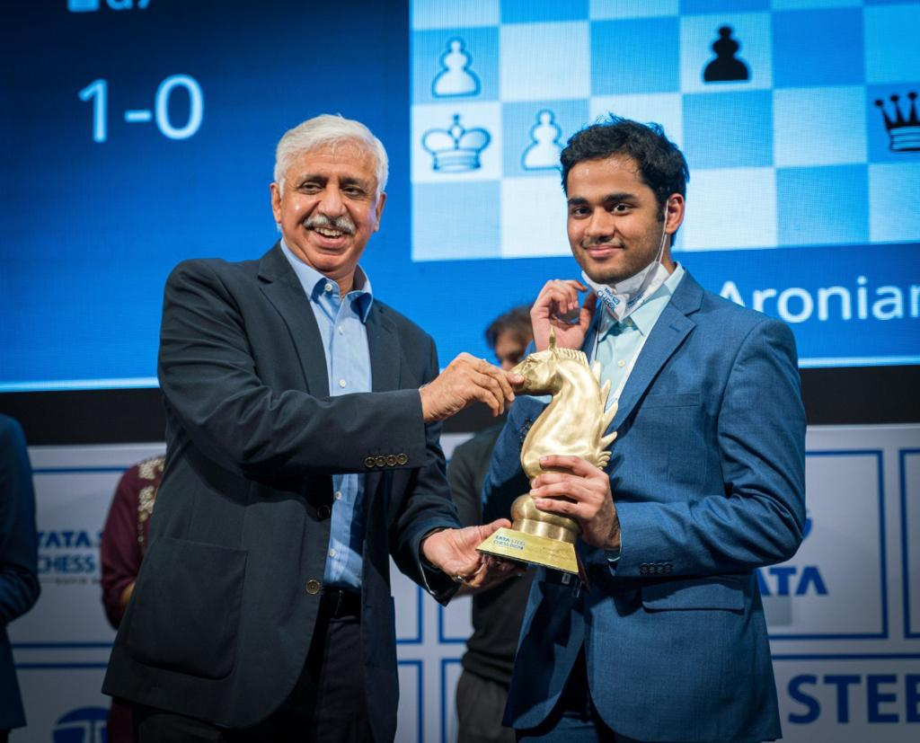

Master ARJUN ERIGAISI First Telangana Grand Master & Young Grand master winner of TATA STEEL RAPID Tournament **“ Chess Icon of Telangana**”